If / else where conditions
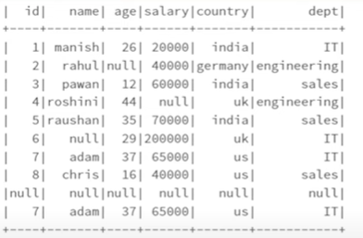
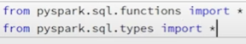
emp-df.withColumn(“adult”,when(col”age”)<18, “No”)
.when(col(“age”)>18, “Yes”)
.otherwise(“Novalue”)).show()
Note : It will create new columns “adults” and if employee age <18 then show no and less then 18 then show yes
Otherwise shoe Novalues
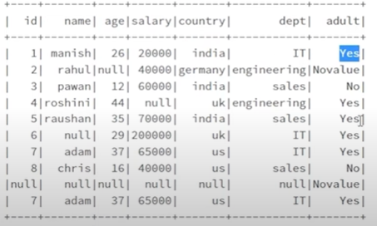
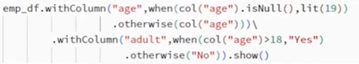
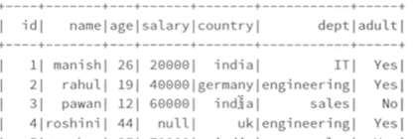

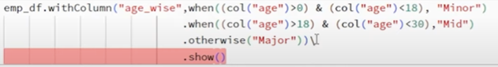
In SQL:
Conver df into tempview as a table
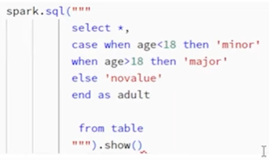

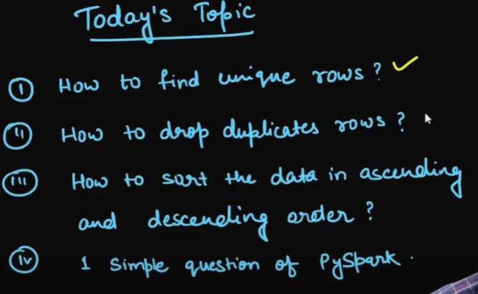

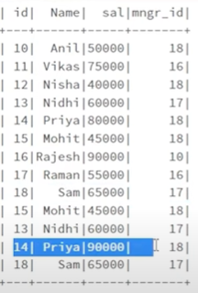
It will show only unique records
Drop duplicate records:
save new df it will have a unique record
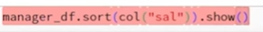
Aggregation:
- Count :- Action :- df.count() Transformation:- df.select (count(“col”))
Count is as action and transformation both depends on use
Count also skip null values
- Min
- Max
- Avg

emp_df.count()
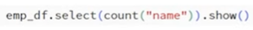

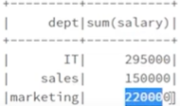
Group By Masterclass:
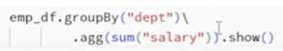

IN SQL:
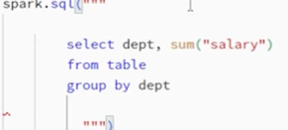

Join in Spark:
df1.join (df2, join expiration, join type)

Show only non common records opposite inner loin

Windows Functions:
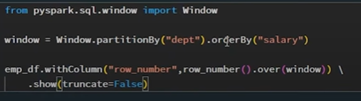
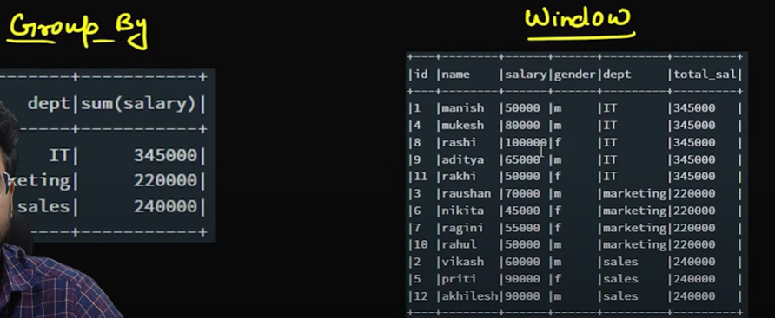
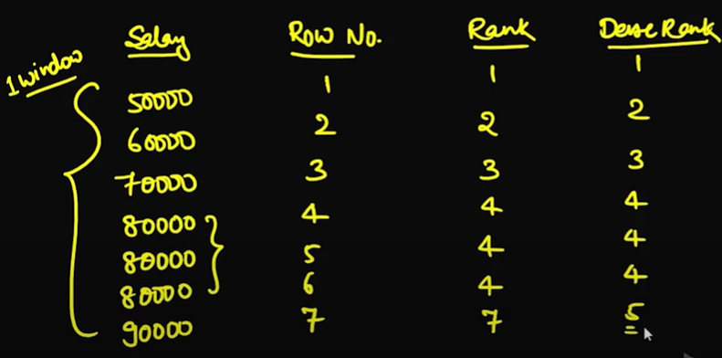

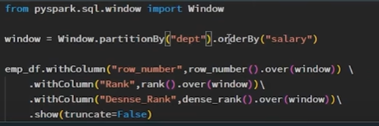

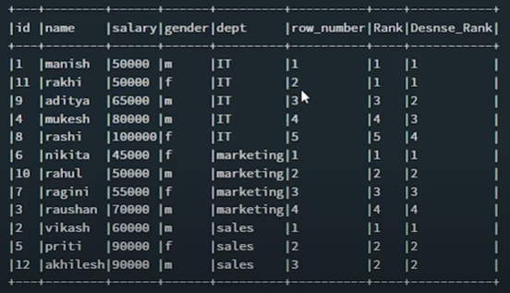

Lead and lag;
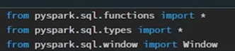
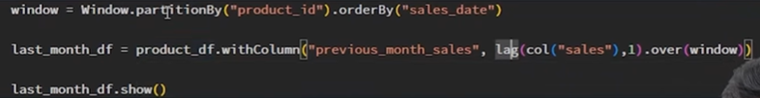
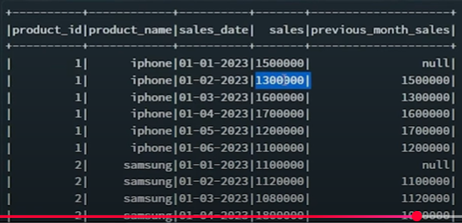
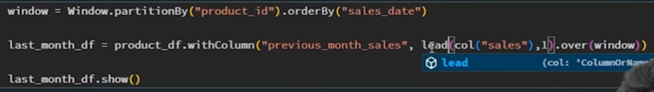

Lag will go 1 record behind, and lead will go 1 records up
Show loss or profit
Range and Rows between: -
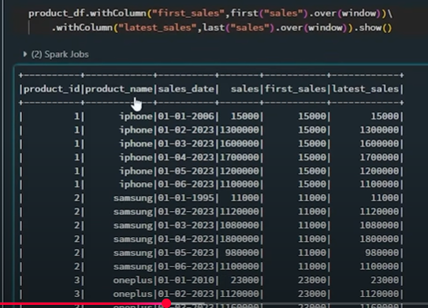

Convert into time stamp

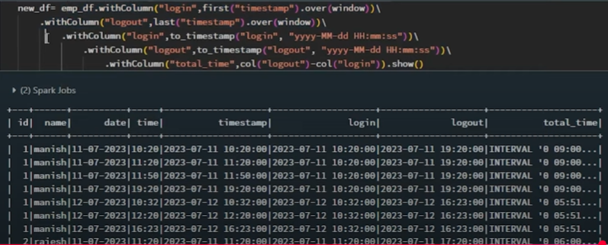
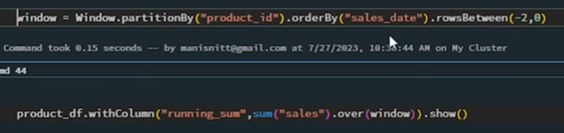

SCD2:
